Daniel Moloney C15446648

4 Database migration Code (for products table check migrations folder for rest)

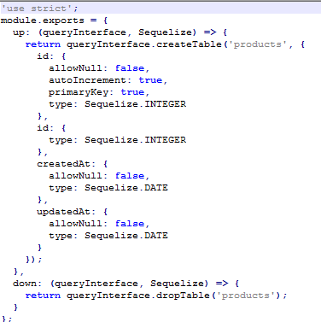

5 populating database with test data (example of purchases table) Code

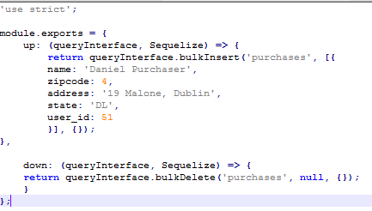

Code for db migrate (already completed so not reupdated)

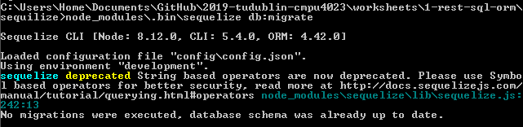

Insertion shown as having been created in the table



6 GET /products[?name=string]

Code

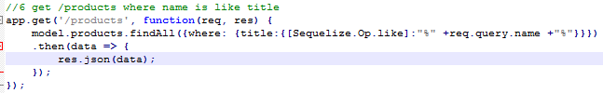

Output

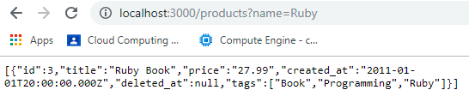

6 GET /products/:id

Code

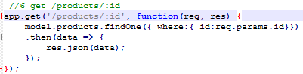

Output

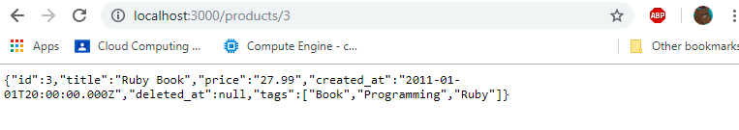

6 /POST /products (adds new entry to products table)

Code

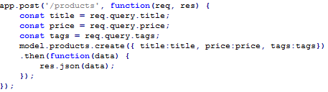

CRUD command (curl)



Output (creation)



6 /PUT/products/:id (Updates existing product entry)

Code

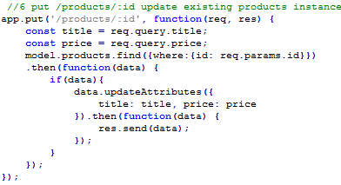

CRUD command(curl)



Output

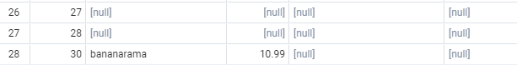

6 /DELETE /products/:id

Code

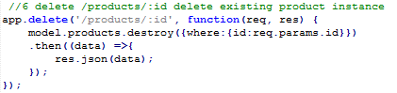

CRUD command (curl)



Output

